

Friends of the Drop-in for Asylum-seekers and Refugees
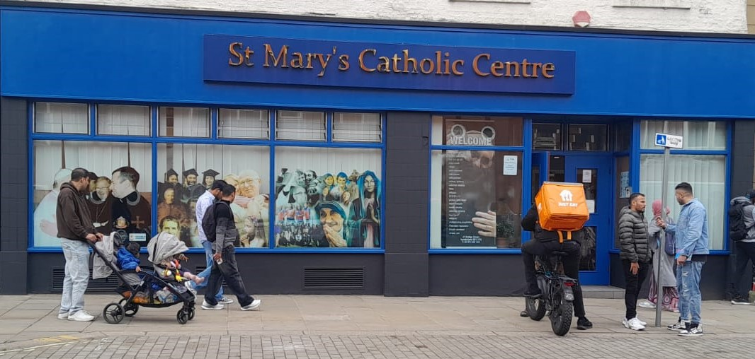
A DROP-IN for asylum seekers and refugees at St Mary’s Catholic Centre, Bridge Street, Sunderland, SR11TQ
EVERY WEDNESDAY 12:00 TO 3:00 PM
- Get registered as a FODI service-user
- Chat over a cup of tea, socialize, make friends, and play games including pool, table tennis, and dominoes
- Register for tickets to see Sunderland AFC (if available)
- Register for our free gym/swim scheme and find out about other sporting opportunities
- Learn about free English classes run by FODI
- Register for free trips to places of local interest
- Share snacks & fruit and the occasional meal for special events
- Register for a donated bicycle by adding your name to the waiting list

For more information, get in touch with Fanni Ngambi Fodi Manager
Email address: f.ngambi@fodisunderland.org
Phone number: 07548758382

